Update **ONLY** the gmail sending method by adding a note to the lead that we send an email via Gmail.   
  
What we need is to add this email template as a note to the lead that we are sending an email to via gmail. I.e this email:   
  
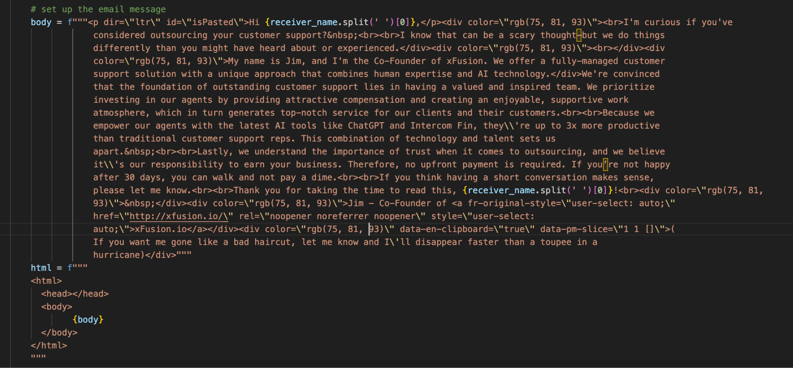  
  
Here is code that we have used to add a note to close before, maybe you can repurpose it.  
  
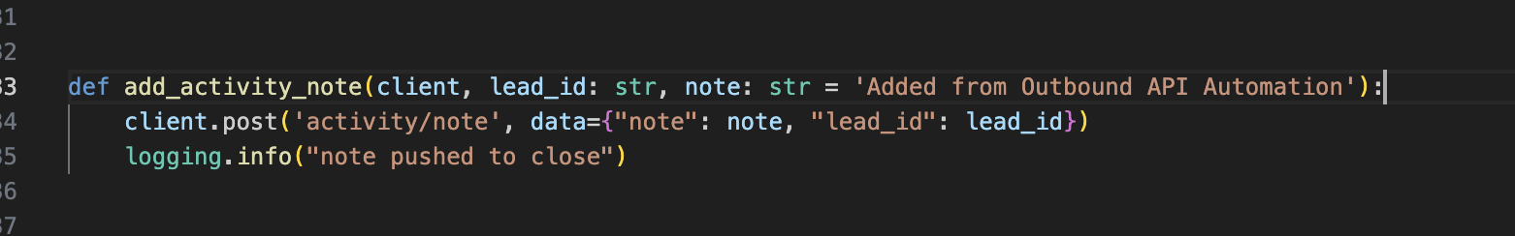

*Please note that this only affects the leads that we contact via Gmail.  
  
Please **ONLY** use this Lead ID for testing **lead_oyE9wA4RjYoX0jPe8cQrC4jgW9gGpzaWIBa92e9dlwH**This lead ID is connected to your email [saifornab@gmail.com](mailto:saifornab@gmail.com) so you can add a Gmail account to the connected_accounts table and use it to send test emails to the lead.

Added to the above we need to save the email template that we have sent to the DB preferably the emails table.  
  
**2nd Part** of this request is making sure that we receive a response back and store it in the DB whenever our email is opened or replied to.  
  
Maybe this library is a good place to start.  
<https://github.com/powergo/pytracking>  
  
This **ONLY** applies to emails that we send directly via Gmail.  
  
What we are looking for is time stamped data i.e in the emails table we can add the below fields:

Email_opened: YES/NO (Boolean)  
No_of_times_opened: 2, 3 …

Email_opened_on: Date & Time(Timestamp)  
Lead_replied: YES/NO (Boolean)

Lead_replied_on: Date & Time(Timestamp)

What we want is when an email is open we track that and save it to the emails table for the lead that opened the email.   
  
If a user opens the email multiple times we would like to track that as well.  
  
Along with the date&time when the user opened the email.

If the lead sends us a reply we would love to record this as well in a YES/NO boolean

Once the reply is send we would like to record that as a YES/NO boolean

***Please note that milestone changes only affect the GMAIL sending part of the script and DB and not the CLOSE part. ***